**STRINGS IN JAVA**

The most commonly used object in java are strings only.

In day to day programming you cannot do anything with out strings.

1.what is diff between string and stringbuffer?

String is immutable(not changeable) string buffer is mutable(can be changed)

|  |
| --- |
| String s=new String(“durga”);  s.concat(“software”);  sopln(s);  String buffer  StringbUffer sb=new StringBuffer(“durga”);  Sb.append(“software”);  Sopln(sb); |

Once string is created it cannot be changed ,if we try to chnge then a new string will be created

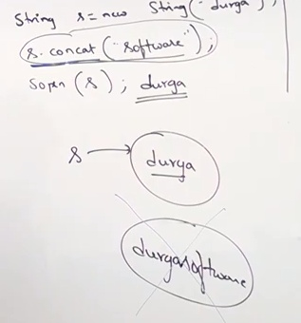

This non changeable property is called immutability.

String buffer

Once you create a string buffer object then you can perform any changes on that object

Because string buffer is mutable

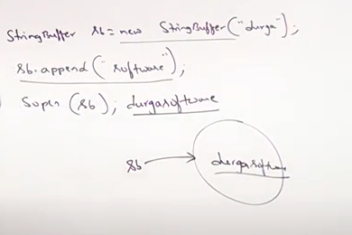

**Case 1:**

|  |
| --- |
| String s1=new String(“durga”);  String s2=new String(“durga”);  Sopln(s1==s2);//flase  Sopln(s1.equals(s2));//true🡪content comparison |

|  |
| --- |
| StringBuffer sb1=new StringBUffer(“durga”);  StringBuffer sb2=new StringBuffer(“durga”);  Sopln(sb1==sb2);//false  Sopln(s1.equals(s2));//false |

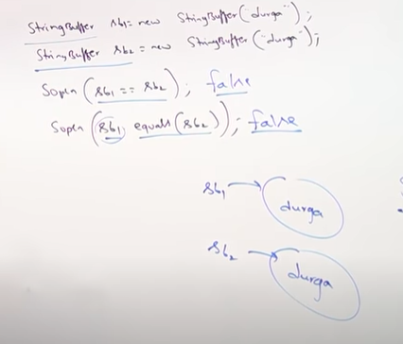

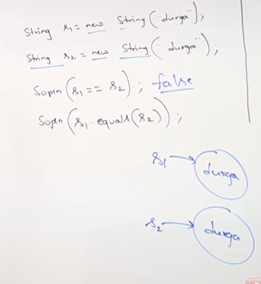

**What is diff in == and .equals method?(Important)**

There is object class and there are two child class String and String Buffer

BY default equals() method in object class is used for reference comparison

Thus is same as ==.

But in string class equals() meant for content comparison.

But in stringbuffer equals() is not meant for content comprions because it is not overridden.

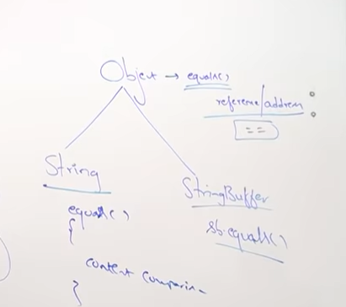

**Case2:**

|  |
| --- |
| String s=new String(“durga”);  2 objetcs will be created one in heap area and the other in the string constant pool.the object in string constant pool is created for future reference purpose.As sson ass we do a new then some area is made in the heap area. |

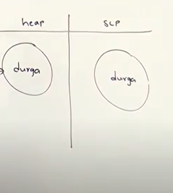

|  |
| --- |
| String s=”durga”;  //in this case only one object is created in the string constant pool and no any in heap area. |

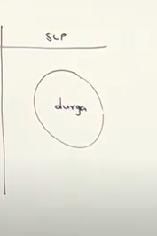

|  |
| --- |
| **String s1=new String(“durga”);** 2 object(1 scp,1 heap)  **String s2=new String(“durga”);**1 object(1 heap)  **Striing s3=”durga”;//no**  **String s4=”durga”;//no**  **//always new wil cresate an object in heap**  **//jvm always check if same object already present in scp then no object created.** |

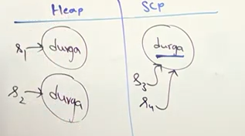

**Note:**In the heap area there can be two objects with same content but in the scp area there can be only an donly one object of same content.

|  |
| --- |
| String s=new String(“durga”);  s.concat(“software”);//because of runtime operation that will be created in the heap are not in scp area.  s=s.concat(“solutions”); |

**NOTE:**For every string litereal a new object is created in the scp.thus object created for “software and “solutions” in the scp.

“Software” is a string constant and for every new constant a n object will be created in the scp area.

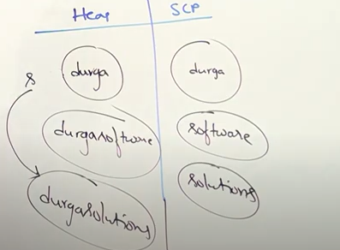

Example:

|  |
| --- |
| String s1=new String(“spring”);  S1.concat(“fall”);  String s2=s1.concat(“winter”);  S2.concat(“summer”);  Sopln(s1);  Sopln(s2); |

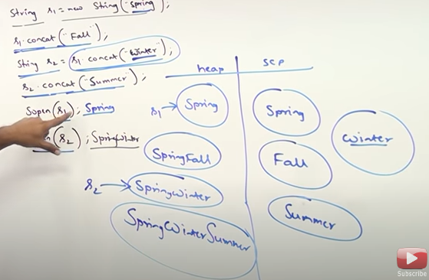

Example:

